 | 12.1.12 Editors - Geometry Nodes Editor - Header - Add Menu - Output
Table of content
Detailed table of content 1
Add menu - Output 1
Enable Output 2
Viewer 3
Warning 3

Detailed table of content
Detailed table of content
Detailed table of content 1
Add menu - Output 1
Enable Output 2
Use 2
Properties 3
Data Type 3
Inputs 3
Enable 3
Value 3
Outputs 3
Viewer 3
Inputs 3
Geometry 3
Warning 3
Inputs 3
Show 3
String 4
Properties 4
Warning type 4
Output 4
Output 4

Add menu - Output
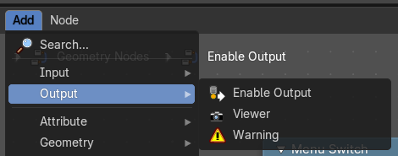
Here you find nodes that outputs data.

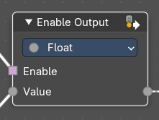
Enable Output
This node allows dynamic control over output visibility in node groups. It simplifies logic where certain output sockets should only be exposed under specific conditions—like menu selections or switch toggles.
This is especially useful for building clean, context-sensitive node groups.

Use
When used inside a Node Group, this node helps to automatically filter or detect outputs.
- If the output always returns a fallback value (e.g. 0, false, empty geometry), this will hide the output socket from the node group output socket interface.
- This behavior is more efficient and user-friendly than using a Switch node, which requires manually setting fallback values per type and will always expose the output socket.
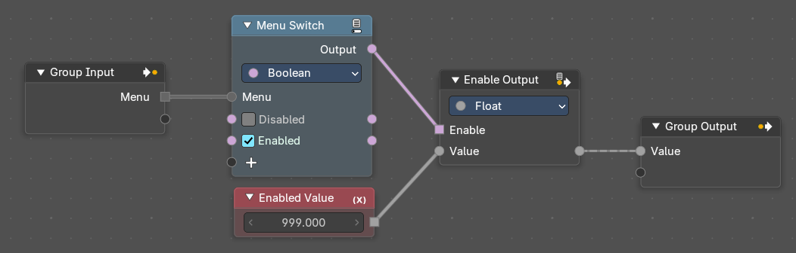
- It’s especially useful in menu-driven setups, where only certain outputs are relevant depending on user selection based on the menu they choose – like the example below

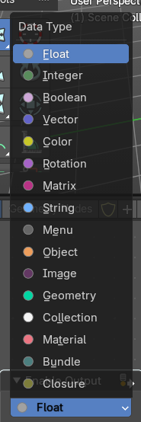

Properties

Data Type
Defines the type of the Value input and output. Options include Float, Vector, Color, Boolean, Geometry, etc. This ensures compatibility with the group output socket.

Inputs

Enable
When True, the node passes the input value through to the output socket. When False, it outputs a fallback value and hides the output socket from the group.

Value
The data to be conditionally passed to the output. Can be Float, Vector, Color, Geometry, etc., depending on the selected Data Type.

Outputs
When True, the node passes the input value through to the output socket. When False, it outputs a fallback value and hides the output socket from the group output interface.

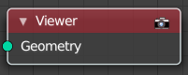
Viewer
This node allows you to output the geometry data of a node in the node tree to the spreadsheet editor.

Inputs

Geometry
Standard geometry input.

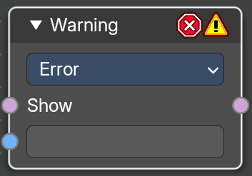
Warning
Allows node groups to throw expectations.

Inputs

Show
Is true or false.

String
The string to show at evaluation.

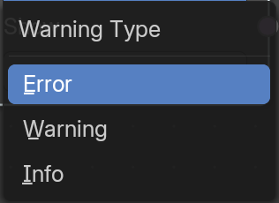
Properties

Warning type
What type the warning should be.

Output

Output
Output the warning string if true.

